HOW TO INSPECT SERVERS AND PORTS

ON WINDOWS – Command Prompt or PowerShell

- Get the list of all servers currently listening at all open ports.
netstat -aon | findstr LISTENING
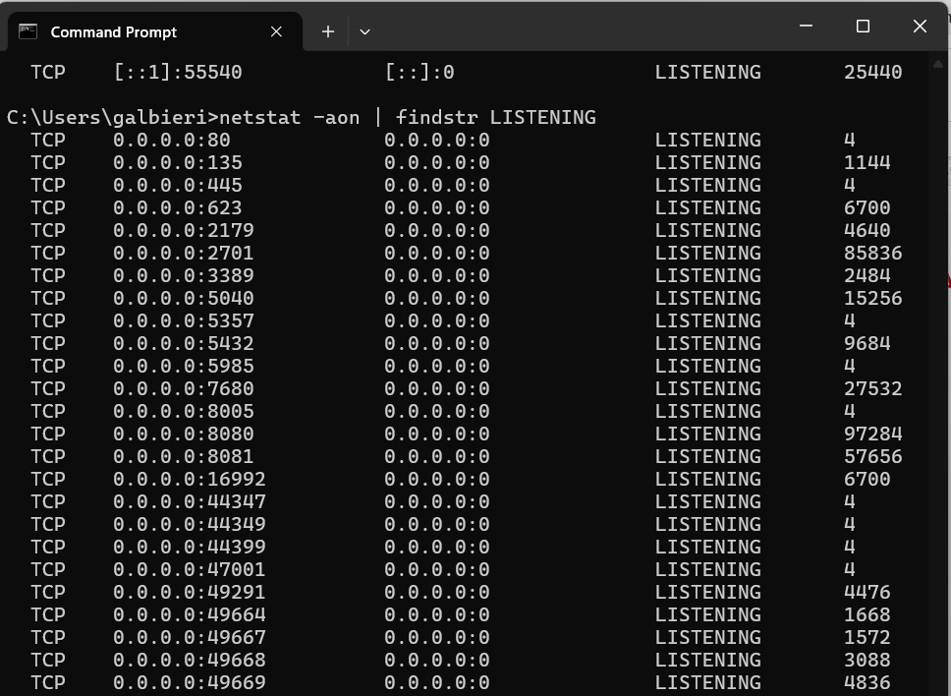

- Search for the specific port we want to shut down.
netstat -ano | findstr :<PortNumber>
netstat -ano | findstr :8080

- Get the PID (Process ID) – i.e. number in the 4th column - of the process running at the searched port and kill it.
taskkill /PID <PID> /F
taskkill /PID 93776 /F

